 |  | 
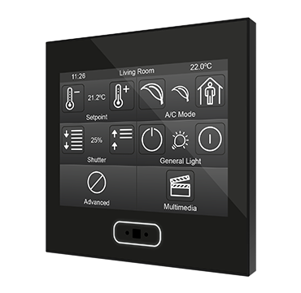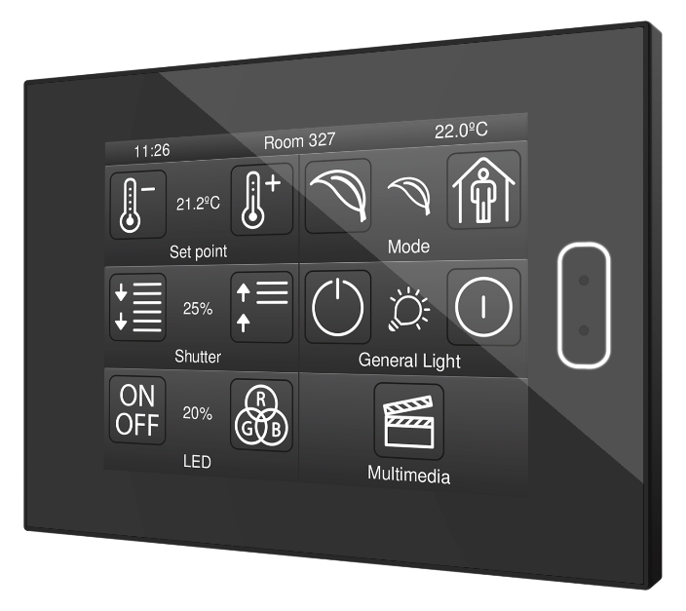

Icon List
 | ZVI-Z35  ZVIZ40 |  | DOCUMENTATION
 | Application Program Version: [3.0]  Document Edition: [3.0]_b |  | DOCUMENTATION
 | www.zennio.com |  | DOCUMENTATION

Nº | Name | Icon |  | Nº | Name | Icon |  | Nº | Name | Icon
1 | No Icon |  |  | 2 | Off 1 |  |  | 3 | On 1 | 
4 | Off 2 |  |  | 5 | On 2 |  |  | 6 | Off 3 | 
7 | On 3 |  |  | 8 | On 4 |  |  | 9 | Off 4 | 
10 | On/Off |  |  | 11 | Accept |  |  | 12 | Cancel | 
13 | Nothing |  |  | 14 | All |  |  | 15 | All/None | 
16 | Light Off 1 |  |  | 17 | Light On 1 |  |  | 18 | Light Off 2 | 
19 | Light On 2 |  |  | 20 | Scene |  |  | 21 | Climate Off | 
22 | Climate On |  |  | 23 | High Temperature |  |  | 24 | Low Temperature | 
25 | Temperature Down |  |  | 26 | Temperature Up |  |  | 27 | Automatic Mode | 
28 | Heat Mode |  |  | 29 | Cool Mode |  |  | 30 | Fan Mode | 
31 | Cool Heat Mode |  |  | 32 | Dry Mode |  |  | 33 | Low Ventilation | 
34 | Medium Ventilation |  |  | 35 | High Ventilation |  |  | 36 | Automatic Ventilation 1 | 
37 | Automatic Ventilation 2 |  |  | 38 | Stop Ventilation |  |  | 39 | Swing On 1 | 
40 | Swing On 2 |  |  | 41 | Swing On 3 |  |  | 42 | Swing Off | 
43 | Ceiling Fan (Decrease) |  |  | 44 | Ceiling Fan (Increase) |  |  | 45 | Automatic | 
46 | Warning: Heat |  |  | 47 | Warning: Cool |  |  | 48 | Warning: Wind | 
49 | Heat Building Protection |  |  | 50 | Cool Building Protection |  |  | 51 | Comfort | 
52 | Standby |  |  | 53 | Economy |  |  | 54 | Underfloor Heating Off 1 | 
55 | Underfloor Heating On 1 |  |  | 56 | Underfloor Heating Off 2 |  |  | 57 | Underfloor Heating On 2 | 
58 | Shutter Open |  |  | 59 | Shutter Close |  |  | 60 | Shutter Move Rightwards | 
61 | Shutter Move Leftwards |  |  | 62 | Shutter Down 1 |  |  | 63 | Shutter Up 1 | 
64 | Shutter Up/Down 1 |  |  | 65 | Shutter Down 2 |  |  | 66 | Shutter Up 2 | 
67 | Shutter Up/Down 2 |  |  | 68 | Forward |  |  | 69 | Backward | 
70 | Next |  |  | 71 | Previous |  |  | 72 | Play | 
73 | Stop |  |  | 74 | Pause |  |  | 75 | Record | 
76 | Eject |  |  | 77 | Volume Up |  |  | 78 | Volume Down | 
79 | Volume Mute |  |  | 80 | Sound 1 |  |  | 81 | Sound 2 | 
82 | Sound 3 |  |  | 83 | Aux |  |  | 84 | Audio/Video | 
85 | TV |  |  | 86 | Clapperboard |  |  | 87 | Frame | 
88 | Monitor |  |  | 89 | Number 0 |  |  | 90 | Number 1 | 
91 | Number 2 |  |  | 92 | Number 3 |  |  | 93 | Number 4 | 
94 | Number 5 |  |  | 95 | Number 6 |  |  | 96 | Number 7 | 
97 | Number 8 |  |  | 98 | Number 9 |  |  | 99 | Rightwards | 
100 | Leftwards |  |  | 101 | Downwards |  |  | 102 | Upwards | 
103 | Arrow Right |  |  | 104 | Arrow Left |  |  | 105 | Arrow Down | 
106 | Arrow Up |  |  | 107 | More |  |  | 108 | Less | 
109 | Lock Closed |  |  | 110 | Lock Opened |  |  | 111 | Enter | 
112 | Leave |  |  | 113 | Key 1 |  |  | 114 | Key 2 | 
115 | Warning |  |  | 116 | Forbidden |  |  | 117 | Door Opened | 
118 | Door Closed |  |  | 119 | Window Opened |  |  | 120 | Window Closed | 
121 | Alarm Clock |  |  | 122 | Sand Clock |  |  | 123 | Clock 1 | 
124 | Clock Off 1 |  |  | 125 | Clock On 1 |  |  | 126 | Clock 2 | 
127 | Clock Off 2 |  |  | 128 | Clock On 2 |  |  | 129 | Shower 1 | 
130 | Shower 2 |  |  | 131 | Shower 3 |  |  | 132 | Shower 4 | 
133 | Shower/WC |  |  | 134 | Shower Zoom |  |  | 135 | Kitchen 1 | 
136 | Kitchen 2 |  |  | 137 | Bathroom 1 |  |  | 138 | Bathroom 2 | 
139 | Bathroom 3 |  |  | 140 | Bedroom |  |  | 141 | Bathing | 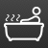
142 | Library |  |  | 143 | Office |  |  | 144 | Restaurant | 
145 | Home |  |  | 146 | Desk |  |  | 147 | Swimming Pool 1 | 
148 | Swimming Pool 2 |  |  | 149 | Living Room |  |  | 150 | New | 
151 | Set |  |  | 152 | OK |  |  | 153 | Auto | 
154 | Stop |  |  | 155 | Stop 2 |  |  | 156 | Eco | 
157 | Restart |  |  | 158 | Tool |  |  | 159 | Configuration | 
160 | Euro |  |  | 161 | kWh |  |  | 162 | Improve | 
163 | Clean 1 |  |  | 164 | Clean 2 |  |  | 165 | Do Not Disturb | 
166 | Towel Rail |  |  | 167 | Bell |  |  | 168 | Plug | 
169 | Wall Plug |  |  | 170 | Heart |  |  | 171 | Sunrise | 
172 | Sunset 1 |  |  | 173 | Sunset 2 |  |  | 174 | Dusk | 
175 | Brightness |  |  | 176 | Contrast 1 |  |  | 177 | Contrast 2 | 
178 | RGB |  |  | 179 | Return Page |  |  | 180 | Timer: Countdown | 
181 | Timer: Cyclical |  |  | 182 | Timer: Once |  |  | 183 | °C | 
184 | °F |  |  | 185 | °C/°F (Celsius) |  |  | 186 | °C/°F (Fahrenheit) | 
187 | Pairing |  |  | 188 | Hearth |  |  | 189 | Bluetooth | 
190 | Decrease |  |  | 191 | Language 1 |  |  | 192 | Language 2 | 
193 | Bedside Lamp |  |  | 194 | Wall Lamp Off 1 |  |  | 195 | Wall Lamp On 1 | 
196 | Wall Lamp Off 2 |  |  | 197 | Wall Lamp On 2 |  |  | 198 | Wall Lamp Off 3 | 
199 | Wall Lamp On 3 |  |  | 200 | Wall Lamp Off 4 |  |  | 201 | Wall Lamp On 4 | 
202 | Ceiling Lamp Off |  |  | 203 | Ceiling Lamp On |  |  | 204 | Led Color 1 | 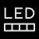
205 | Led Color 2 |  |  | 206 | Led On/Off |  |  | 207 | Book | 
208 | Clean Room 1 |  |  | 209 | Clean Room 2 |  |  | 210 | Ceiling Light Off | 
211 | Ceiling Light On |  |  | 212 | Bedside Table |  |  | 213 | Manual Mode | 
214 | Do Not Disturb 1 |  |  | 215 | Do Not Disturb 2 |  |  | 216 | Room Normal State | 
217 | Source |  |  | 218 | WC |  |  | 219 | Danger Building Protection | 
220 | Door and Window Opened |  |  | 221 | Active Alarm Clock |  |  | 222 | Disabled Alarm Clock | 

Join and send us your inquiries
about Zennio devices:
https://support.zennio.com
Zennio Avance y Tecnología S.L.  C/ Río Jarama, 132. Nave P-8.11  45007 Toledo (Spain).  Tel. +34 925 232 002.  www.zennio.com  info@zennio.com |  |  |  |  |  | 

